Precut Scrap Quilt Workshop with Val

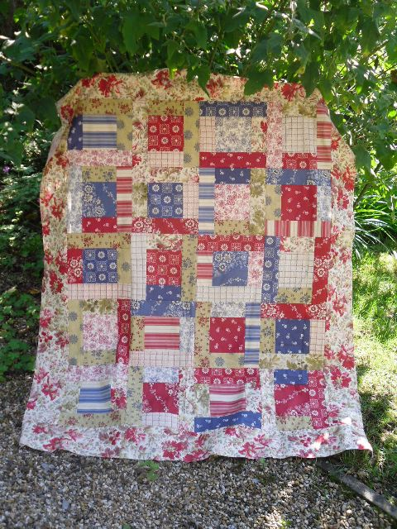

You will need:
20 pre-cut squares @ 5”
20 strips @ 2 ½” x 42”
Plus border approx 75cm (assuming fabric is 42” wide)

To Make 20 blocks:
Quilt will be set 4 squares across x 5 rows down.
Sewing: ¼” seam allowance is assumed but not essential
Select the 20 pre-cut 5” squares
Take the 20 strips and cut 2 x 5” rectangles from each
Audition these 5” rectangles above and below the squares in a pleasing manner –
could be identical fabrics;
could be similar;
could be completely different
TIP: the sample has different fabrics
Sew these onto the squares:
Press and measure
You should be around 9”: make a note of this measurement
TIP: If your measurement is larger then your seam allowance is a little small and if the measurement is smaller then your seam allowance is a little large BUT IT DOESN’T MATTER – just be consistant.
From the strips you now need to cut 40 rectangles at this measurement – i.e. two from each strip would give you this so use as many of the fabrics as possible
Again audition against the squares and sew into place to give a square.
Arrange the completed squares in a pleasing sequence 4 across x 5 down – if you turn the alternate squares you will avoid having seams in the middle of the block to match and avoid having a strong horizontal line in your quilt.
Add a border (if you want) – anything up to 6” will work.
Layer quilt and bind –all the leftover strips can be used up in the binding and if necessary you could add a bit of the border leftovers too.

© Valerie Nesbitt 2013

